

International School
Elements of Network Security
CMU-CS 376 CIS
Report Document

STUDY OF IPsec AND IMPLEMENTATION OF A SITE-TO-SITE VPN TO PROTECT CONNECTIVITY BETWEEN TWO BRANCHES IN A VIRTUAL MACHINE ENVIRONMENT

Project Mentor: Le Van Tinh

Created by: Cao Thi Vuong Anh
Student ID: 30209232987

Danang, September 10th, 2026

PROJECT INFORMATION
Table 0.1. Project information
Information Field | Content
Project Acronym | IPSEC-S2S-LAB
Project Title | Study of IPsec and Implementation of a Site-to-Site VPN for Securing Connectivity Between Two Branches in a Virtualized Environment
Student – ID | Cao Thị Vương Anh - 30209232987
Instructor | Le Van Tinh
Duration | 3 weeks
GitHub
Video | https://youtu.be/djVERrUjKfU
Email | vuonganhh0602@gmail.com

REVISION HISTORY
Table 0.2. Revision History by Work Milestone
Version | Phase | Description
Draft | Week 1 | Defined the IPsec scope, addressing plan, and test scenarios.
v1.0 | Week 2 | Built two virtual machines and configured IKEv1 with ESP Tunnel Mode.
v1.1 | Week 3 | Collected SA status, ping results, PCAP files, and performed the incorrect PSK test.
v2.0 | Week 3 | Completed the report and demonstration video.

TABLE OF CONTENTS
THÔNG TIN DỰ ÁN 2
LỊCH SỬ SỬA ĐỔI 2
MỤC LỤC 3
DANH MỤC HÌNH ảnh 5
DANH MỤC BẢNG 5
DANH MỤC TỪ VIẾT TẮT 5
CHƯƠNG 1. GIỚI THIỆU 6
1.1. MỤC ĐÍCH TÀI LIỆU 6
1.2. MỤC TIÊU VÀ TIÊU CHÍ ĐÁNH GIÁ 6
1.3. PHẠM VI VÀ PHƯƠNG PHÁP 7
CHƯƠNG 2. CĂN CỨ LỰA CHỌN CÔNG NGHỆ 7
2.1. TIÊU CHÍ LỰA CHỌN 7
2.2. CÔNG CỤ THỰC NGHIỆM 7
CHƯƠNG 3. PHÂN RÃ CÔNG VIỆC VÀ LỘ TRÌNH 8
3.1. TRÁCH NHIỆM CÁ NHÂN 8
3.2. KẾ HOẠCH BA TUẦN 8
CHƯƠNG 4. TỔNG QUAN CÔNG NGHỆ CỐT LÕI 8
4.1. KHUNG KIẾN TRÚC IPsec 8
4.2. SECURITY POLICY DATABASE VÀ SECURITY ASSOCIATION 9
4.3. AH VÀ ESP 9
4.4. TRANSPORT MODE VÀ TUNNEL MODE 10
4.5. IKEv1 VÀ QUÁ TRÌNH THƯƠNG LƯỢNG 10
4.6. IKEv1 MAIN MODE 10
4.7. IKEv1 QUICK MODE 11
4.8. THUẬT TOÁN MẬT MÃ TRONG MÔ HÌNH 11
4.9. XÁC THỰC BẰNG PRE-SHARED KEY 12
4.10. TIÊU CHUẨN, GIỚI HẠN VÀ HƯỚNG PHÁT TRIỂN 12
CHƯƠNG 5. THIẾT KẾ VÀ TRIỂN KHAI THỰC NGHIỆM 12
5.1. KIẾN TRÚC MẠNG VÀ ĐIỂM BẮT GÓI 12
5.2. CÁC BƯỚC TRIỂN KHAI 13
5.3. KIỂM THỬ VÀ KẾT QUẢ 13
5.3.1. XÁC NHẬN CẤU HÌNH HAI GATEWAY 14
5.3.2. THIẾT LẬP IPsec VÀ TRẠNG THÁI SECURITY ASSOCIATION 15
5.3.3. PHÂN TÍCH IKEv1 MAIN MODE 15
5.3.4. PHÂN TÍCH IKEv1 QUICK MODE 16
5.3.5. PHÂN TÍCH ESP SA 16
5.3.6. KIỂM TRA LƯU LƯỢNG QUA ĐƯỜNG HẦM 17
5.3.7. ĐỐI CHIẾU LƯU LƯỢNG TẠI LAN VÀ WAN 18
5.3.8. KIỂM THỬ PRE-SHARED KEY KHÔNG KHỚP 19
5.4. ĐÁNH GIÁ KẾT QUẢ VÀ GIỚI HẠN 20
CHƯƠNG 6. KẾT LUẬN VÀ HƯỚNG PHÁT TRIỂN 20
6.1. KẾT LUẬN 20
6.2. HẠN CHẾ VÀ HƯỚNG PHÁT TRIỂN 20
6.3. SẢN PHẨM NỘP 21
CHƯƠNG 7. TÀI LIỆU THAM KHẢO 21
PHỤ LỤC A. LỆNH KIỂM TRA VÀ MINH CHỨNG 21

LIST OF FIGURES
Figure 5.1. IP Address Configuration on Gateway A
Figure 5.2. IP Address Configuration on Gateway B
Figure 5.3. IPsec Site-to-Site Status After Successful Establishment
Figure 5.4. IKEv1 Main Mode Messages in Wireshark
Figure 5.5. IKEv1 Quick Mode Process in Wireshark
Figure 5.6. SPI and Sequence Number Fields in an ESP Packet
Figure 5.7. ICMP Connectivity Test Results Through the IPsec VPN
Figure 5.8. ICMP Packets Observed at the LAN Capture Point
Figure 5.9. ESP Traffic Observed at the WAN Capture Point
Figure 5.10. IKEv1 Negotiation Error Caused by a Mismatched Pre-Shared Key
Figure 5.11. IKE SA and ESP Tunnel Status After Restoring the Pre-Shared Key

LIST OF TABLES
Table 0.1. Project Information
Table 0.2. Revision History by Work Milestone
Table 0.3. Terms Used in the Report
Table 1.1. Objectives and Scope of Evidence
Table 2.1. Tools Used in the Experiment
Table 3.1. Three-Week Implementation Schedule
Table 5.1. Addresses and Capture Points
Table 5.2. Summary of Test Scenarios and Evidence

LIST OF ABBREVIATIONS
Table 0.3. Terms Used in the Report
Abbreviation | Meaning
IPsec | Internet Protocol Security
VPN | Virtual Private Network
IKE | Internet Key Exchange
ESP | Encapsulating Security Payload
SA | Security Association
SPI | Security Parameters Index
PSK | Pre-Shared Key
ICMP | Internet Control Message Protocol
CIA | Confidentiality, Integrity, Availability
AH | Authentication Header
SPD | Security Policy Database
HMAC | Hash-based Message Authentication Code
PRF | Pseudorandom Function
WAN | Wide Area Network
LAN | Local Area Network

CHAPTER 1. INTRODUCTION

1.1. Purpose of the document
This report describes the design, configuration, and evaluation of a Site-to-Site IPsec VPN tunnel in a VirtualBox environment. The scenario involves two enterprise networks that need to exchange data across an intermediate network. The report presents the basis for technology selection, the IPsec mechanism, the experimental configuration, and results supported by screenshots and PCAP files.

1.2. Objectives and evaluation criteria
The objectives are to establish an IKE session between two gateways, install ESP Tunnel Mode for two LAN subnets, verify connectivity using ICMP, analyze packets at two capture points, and examine the response when the two sides use different PSKs. Regarding the CIA triad, confidentiality is observed through ESP packets on the WAN; integrity and authentication are explained through the negotiated algorithms and the incorrect-PSK test; availability is assessed only through ping tests and tunnel recovery. These results do not constitute an operational availability guarantee.
Table 1.1. Objectives and Scope of Evidence
Objective | Available Evidence | Limitation
Operational tunnel | ESTABLISHED and INSTALLED, TUNNEL | Two gateway VMs only
VPN connectivity | Ping 4/4, 0% packet loss; ESP counter increased | ICMP only; no throughput measurement
Packet observation | ICMP observed at the LAN; ESP observed on the WAN | No packet-by-packet decryption verification
PSK authentication | Incorrect PSK caused negotiation errors; the tunnel was restored successfully | No denial-of-service resistance test

1.3. Scope and methodology
The project was implemented in an Oracle VirtualBox virtualized environment with two Ubuntu Server virtual machines acting as Gateway A and Gateway B. Gateway A uses WAN address 10.10.10.1/24 and LAN address 192.168.10.1/24, while Gateway B uses WAN address 10.10.10.2/24 and LAN address 192.168.20.1/24. The two network ranges configured as traffic selectors are 192.168.10.0/24 and 192.168.20.0/24. These addressing parameters match the experimental model described in this report.
Regarding the protocol scope, the project uses strongSwan with IKEv1, a Pre-Shared Key, and ESP Tunnel Mode. Main Mode is used in Phase 1, while Quick Mode is used in Phase 2. AH, IKEv2, and certificate-based authentication are outside the implementation scope. The experiment focuses on inspecting SA status, transmitting ICMP traffic, analyzing IKE and ESP packets with Wireshark, and testing a mismatched PSK. The model does not include separate endpoint machines, application services such as HTTP, DoS testing, replay attacks, long-term performance measurements, or an AI/ML system. This scope is consistent with the limitations documented in the current report.
The project follows a method that combines literature review and experimentation. First, technical documents and RFCs related to IPsec, ESP, and IKEv1 were reviewed to identify the operating principles, the Security Association establishment process, and traffic protection mechanisms. Next, two gateways were built in VirtualBox and configured with strongSwan to establish a Site-to-Site IPsec connection. Commands such as ipsec statusall and ping were used to inspect tunnel status and data transmission capability. Wireshark was used to analyze the ipsec_full.pcap, lan_plain.pcap, and wan_esp.pcap files, allowing comparison between traffic observed at the LAN and WAN capture points. Finally, a controlled Pre-Shared Key mismatch was introduced to observe IKEv1 negotiation errors. After recording the results, the PSK was restored and the connection was re-established to confirm normal tunnel operation.

CHAPTER 2. TECHNOLOGY SELECTION

2.1. Selection criteria
The tools needed to run on a personal computer, isolate virtual networks, store configurations in files, generate readable IKE logs, and export packets for Wireshark analysis. VirtualBox and Ubuntu Server meet these practical requirements with limited resources. strongSwan provides the ipsec command for status inspection, while Wireshark supports comparison between ICMP and ESP traffic. Cisco devices and GNS3 were not used in this experimental model.

2.2. Experimental tools
Table 2.1. Tools Used in the Experiment
Category | Tool | Role
Virtualization | Oracle VirtualBox | Hosts the two gateway VMs and isolated virtual networks.
Operating System | Ubuntu Server 24.04.5 ISO | Guest operating system; the observed kernel version is 6.8.0-139-generic.
IPsec | strongSwan 5.9.13 | Performs IKEv1 negotiation and installs ESP.
Verification | ping, ipsec statusall | Verifies connectivity and Security Association status.
Capture and Analysis | tcpdump, Wireshark | Captures and analyzes lan_plain.pcap and wan_esp.pcap.

CHAPTER 3. WORK BREAKDOWN AND SCHEDULE

3.1. Individual responsibilities
I reviewed technical documents, designed the network addressing plan, installed the virtual machines, configured IPsec, performed the tests, collected evidence, and prepared the report and video. The values presented in the tables were observed directly from the screenshots. Secret configuration details were excluded from the video and public appendices.

3.2. Three-week plan
Table 3.1. Three-Week Implementation Schedule
Week | Tasks | Deliverables
1 | Reviewed the guidelines and RFCs; finalized IP addresses, scope, and test scenarios. | Network topology and project proposal.
2 | Built the VMs and established connectivity between the two gateways and IPsec. | Configuration and statusall output.
3 | Captured packets, tested an incorrect PSK, restored the configuration, and prepared the report and video. | PCAP files, supporting screenshots, and report.

CHAPTER 4. CORE TECHNOLOGY OVERVIEW

4.1. IPsec architectural framework
IPsec (Internet Protocol Security) is a security architecture operating at the network layer, designed to protect IP traffic between hosts or security gateways. Rather than being a single protocol, IPsec is a framework that combines multiple components, including security policies, Security Associations (SAs), data-protection protocols, and key-management mechanisms.
According to RFC 4301, IPsec processing relies on policies to determine whether traffic is allowed to pass directly, discarded, or protected by IPsec. Operating at the IP layer allows upper-layer applications to use the protected connection without requiring changes to their individual logic [3]. RFC 4301 also defines two main IPsec operating modes: Transport Mode and Tunnel Mode. When the connection endpoints are security gateways, Tunnel Mode is the commonly used model.
In this project, IPsec is implemented between two Ubuntu gateways to protect traffic between the 192.168.10.0/24 and 192.168.20.0/24 networks. Data is protected by ESP in Tunnel Mode, while IKEv1 is used to negotiate parameters and establish Security Associations.

4.2. Security policy database and security association
Security Policy Database (SPD) stores policies that define how a system processes traffic crossing the IPsec boundary. For each IP packet, a policy may require one of three actions: BYPASS, DISCARD, or PROTECT. If traffic must be protected, the system uses the corresponding Security Association to determine the algorithms, keys, operating mode, and required parameters [3].
A Security Association is a collection of security parameters used to protect traffic in one direction. Since an SA is unidirectional, a bidirectional IPsec connection requires appropriate SAs for both transmission directions. An SA may contain information such as encryption algorithms, integrity-checking algorithms, cryptographic keys, the SPI, and Transport or Tunnel Mode.
In the ipsec statusall output of the experimental model, strongSwan displays the IKE SA in the ESTABLISHED state and the CHILD_SA in the INSTALLED, TUNNEL state. This indicates that negotiation has completed and that the SA for ESP traffic between the two networks has been installed.

4.3. AH and ESP
defines two main data-protection protocols: Authentication Header (AH) and Encapsulating Security Payload (ESP). AH focuses on data-origin authentication and integrity protection but does not provide encryption of the content. Since the objective of this project is to protect the confidentiality of data transmitted between two branches, AH is not used in the experimental model.
ESP is more suitable for this requirement because it can provide confidentiality through encryption while also supporting data-origin authentication, data integrity, and anti-replay mechanisms, depending on the SA configuration. RFC 4303 states that ESP can provide confidentiality, data-origin authentication, connectionless integrity, and anti-replay services [4].
In this lab, ESP is configured with AES_CBC_256 for encryption and HMAC_SHA2_256_128 for integrity checking. Therefore, the inner IP packet content is not directly visible at the WAN capture point. However, using ESP does not mean that all information on the transmission path is hidden. The outer IP addresses of the two gateways, the ESP protocol, SPI, Sequence Number, packet size, and packet timing can still be observed in Wireshark.

4.4. Transport mode and Tunnel mode
In Transport Mode, IPsec mainly protects the payload of the original IP packet while retaining the original IP header for routing. This mode is more suitable for certain direct host-to-host communication scenarios.
In Tunnel Mode, the entire original IP packet is encapsulated inside a new IP packet. A new outer IP header is created to transmit data between the two tunnel endpoints. Therefore, the addresses of the internal networks can be protected from direct observation on the intermediate network. RFC 4301 specifies Tunnel Mode as the typical model when an SA is established between two security gateways [3].
The project model uses the following configuration: outer tunnel 10.10.10.1 ↔ 10.10.10.2 and protected networks 192.168.10.0/24 ↔ 192.168.20.0/24. At the LAN capture point, Wireshark can observe source address 192.168.10.1, destination address 192.168.20.1, and ICMP Echo Request packets. In contrast, at the WAN capture point, only ESP packets between 10.10.10.1 and 10.10.10.2 are directly observed. This result clearly illustrates the difference between the inner IP packet and the tunnel packet transmitted across the intermediate network.

4.5. Ikev1 and the negotiation process
IKE (Internet Key Exchange) is used to automatically negotiate policies, perform authentication, and generate keying material for IPsec. In IKEv1, the negotiation process is divided into two main phases. Phase 1 establishes a secure and authenticated management channel between the two peers, also known as an ISAKMP SA. Main Mode and Aggressive Mode belong to Phase 1. Phase 2 is used to negotiate the SAs that support IPsec, and Quick Mode performs this function [5].
This project uses only Main Mode for Phase 1 and Quick Mode for Phase 2. Aggressive Mode and IKEv2 are not used in the experimental implementation.

4.6. IKEv1 main mode
Main Mode is used in Phase 1 to establish an IKE SA between the two gateways. The process includes three main exchanges, corresponding to six IKE messages. These steps negotiate the IKE policy, exchange information for key generation, and finally authenticate the identities of both peers.
RFC 2409 defines Main Mode as a Phase 1 mechanism and provides better identity protection than directly transmitting identification information at the beginning of the negotiation process [5].
In the experimental ipsec_full.pcap file, Wireshark identifies the initial packets as Identity Protection (Main Mode). The observed proposal includes AES-CBC with a 256-bit key, SHA2-256, Diffie–Hellman MODP 2048, and Pre-Shared Key authentication. This is direct evidence of the IKE SA establishment process in the model.

4.7. IKEv1 quick mode
After the IKE SA is established, Quick Mode is performed in Phase 2 to negotiate policies and keying material for the SAs that protect IPsec data traffic. Quick Mode depends on Phase 1, and its payloads are protected by the previously established IKE SA [5].
In the experiment, Wireshark identifies three Quick Mode packets following Main Mode. Their content is displayed as Encrypted Data, which is consistent with Quick Mode being protected by the IKE SA. After negotiation completes, strongSwan shows that the CHILD_SA has been established with ESP and Tunnel Mode.
The process can be summarized as follows: IKEv1 Main Mode → IKE SA → Quick Mode → ESP SA → Protected Traffic. This sequence is also consistent with the experimental log: IKE_SA ... established appears first, followed by CHILD_SA ... established, and finally strongSwan reports that the site-to-site connection was established successfully.

4.8. Cryptographic algorithms in the model
Based on the log and the ipsec statusall command, the experimental model records the following IKE proposal: AES_CBC_256 / HMAC_SHA2_256_128 / PRF_HMAC_SHA2_256 / MODP_2048, and the following ESP proposal: AES_CBC_256 / HMAC_SHA2_256_128.
AES-CBC-256 performs data encryption; HMAC-SHA2-256 supports integrity checking and authentication; the PRF is used for deriving IKE keying material; and MODP 2048 is used in the Phase 1 key-exchange process.
The SPI (Security Parameters Index), which appears in the ESP header, helps the receiving endpoint identify the appropriate SA for processing a packet. The Sequence Number increases across packets within the same SA and is part of ESP’s anti-replay mechanism [4]. SPI and Sequence Number can be observed in the project’s Wireshark capture; however, the project does not perform replay-attack testing and therefore does not draw an experimental conclusion about anti-replay capability.

4.9. Pre-shared key authentication
The model uses a Pre-Shared Key to authenticate the two gateways during IKEv1 negotiation. The basic requirement is that both peers must use matching credentials. If the PSKs do not match, the authentication process cannot be completed and the SAs for IPsec are not established. This was verified in the lab by intentionally making the PSKs on the two gateways different.
The log displayed messages such as invalid HASH_V1 payload length, decryption failed, and could not decrypt payloads, while the session did not reach the INSTALLED, TUNNEL state. After the PSK was synchronized again and strongSwan reloaded the credentials, the IKE SA and CHILD_SA were successfully established. This scenario was intended only to test an authentication-configuration error in a controlled environment and must not be considered an attack on a real system.

4.10. Standards, limitations, and future directions
The main standards used for comparison in this project are RFC 4301 on the IPsec architecture, RFC 4303 on ESP, and RFC 2409 on IKEv1 [3]–[5]. However, IKEv1 is no longer recommended for new deployments. RFC 9395 moved IKEv1 and related documents to Historic status and identified IKEv1 as a deprecated protocol [6]. Therefore, the use of IKEv1 in this project is intended for learning and direct analysis of Main Mode, Quick Mode, and the IPsec establishment process, rather than as a proposed architecture for a production environment.
As future work, the model can be migrated to IKEv2, use certificates instead of PSKs, and include centralized log-monitoring mechanisms. If a sufficiently large dataset is collected from multiple negotiation sessions, statistical analysis or Machine Learning methods could be investigated to detect anomalies such as a sudden increase in failed negotiations, repeated authentication failures, or frequent tunnel re-establishment. However, AI/ML was not implemented in the current project and is therefore not presented as an experimental result.

CHAPTER 5. EXPERIMENTAL DESIGN AND IMPLEMENTATION

5.1. Network architecture and packet-capture points
Table 5.1. Addressing and Observation Points
Device / Point | Observed Address or File | Function
GW-A | WAN 10.10.10.1; LAN 192.168.10.1 | Initiates the connection and sends ping traffic.
GW-B | WAN 10.10.10.2; LAN 192.168.20.1 | The remote endpoint of the tunnel.
Protected domains | 192.168.10.0/24 ↔ 192.168.20.0/24 | Traffic selectors.
LAN capture point | lan_plain.pcap | Observes ICMP packets before ESP encapsulation.
WAN capture point | wan_esp.pcap | Observes ESP packets between the two gateways.
The WAN segment is an isolated virtual network rather than the public Internet. The available evidence shows traffic originating from the LAN address of GW-A and sent to the LAN address of GW-B. The two network ranges are configured as traffic selectors; however, separate Client-A and Server-B endpoint machines have not been demonstrated. These endpoint machines may be added when the lab is extended.

5.2. Implementation steps
Two Ubuntu Server VMs were allocated approximately 2 GB of RAM and 2 vCPUs each during the lab setup stage. On GW-A, the site-to-site connection uses 10.10.10.1 and 10.10.10.2, with traffic domains 192.168.10.0/24 and 192.168.20.0/24. The PSK is stored in /etc/ipsec.secrets. This report records the verification and control commands that were executed but does not reproduce the secret key.
- sudo ipsec statusall — Displays the IKE session and ESP SAs.
- ping -c 4 10.10.10.2 — Verifies connectivity between the two WAN endpoints while the tunnel is down.
- sudo ipsec up site-to-site — Initiates Main Mode and Quick Mode negotiation.
- ping -c 4 192.168.20.1 — Tests traffic within the protected domain.
- sudo ipsec down site-to-site — Closes the session before the incorrect-key test.
- sudo ipsec rereadsecrets — Reloads the PSK after a change on GW-B.
For the incorrect-key scenario, the /etc/ipsec.secrets file on GW-B was backed up before modification, then restored and reloaded. The complete configuration names, addresses, and algorithms should be verified against the two original configuration files before submitting the appendix; the current screenshots are insufficient to reproduce every configuration line exactly.

5.3. Testing and results
Testing was conducted sequentially: verifying baseline connectivity, establishing IKEv1, creating the ESP Security Association, transmitting traffic through the tunnel, analyzing packets at the LAN and WAN capture points, and finally testing the case where the two gateways used mismatched Pre-Shared Keys. The results were verified using strongSwan status output, ping, and PCAP files captured and analyzed with Wireshark.
Table 5.2. Summary of Tests and Evidence
ID
  Action
  Actual Observation
  Conclusion
T01
  Brought down the tunnel; ran statusall; pinged the WAN endpoint
  0 up, 0 connecting; ping to 10.10.10.2 received 4/4 replies with 0% packet loss.
  WAN connectivity was operational.
T02 | ipsec up; statusall | 1 up, 0 connecting; ESTABLISHED; INSTALLED, TUNNEL. | IKEv1 and ESP were operational.
T03 | Pinged the LAN-B address | Ping to 192.168.20.1: 4/4 replies, 0% packet loss; ESP counter: 336 bytes / 4 packets in one direction. | Traffic passed through the SA.
T04 | Opened LAN/WAN PCAP files | LAN: 4 ICMP Echo Requests; WAN: 8 ESP packets with SPI and Sequence Number. | The WAN showed ESP rather than directly visible ICMP.
T05 | Changed the PSK incorrectly and reinitiated the connection | Log decryption failed; 0 up, 1 connecting sau khi dừng CLI; không có INSTALLED. | The tunnel was not established when the PSKs differed.
T06 | Restored the PSK and brought the tunnel up again | 1 up, 0 connecting; INSTALLED, TUNNEL. | Connectivity was successfully restored.

5.3.1. Verification of the two gateway configurations
Before establishing IPsec, the network addresses on both gateways were checked to ensure that the WAN and LAN interfaces had been configured according to the design. GW-A uses WAN address 10.10.10.1/24 and LAN address 192.168.10.1/24, while GW-B uses WAN address 10.10.10.2/24 and LAN address 192.168.20.1/24.
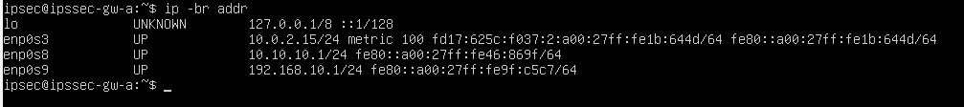
Figure 5.1. IP Address Configuration on Gateway A
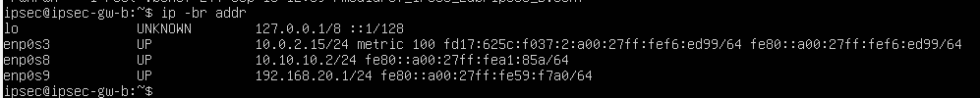
Figure 5.2. IP Address Configuration on Gateway B
The WAN addresses 10.10.10.1 and 10.10.10.2 establish connectivity between the two gateways, while the networks 192.168.10.0/24 and 192.168.20.0/24 are defined as the traffic domains to be protected by IPsec.

5.3.2. Psec establishment and security association status
After initiating the connection with the command sudo ipsec up site-to-site, strongSwan completed IKEv1 negotiation and established the SAs for ESP. The ipsec statusall command showed the IKE SA in the ESTABLISHED state and the CHILD_SA in the INSTALLED, TUNNEL state. The traffic selectors were defined between 192.168.10.0/24 and 192.168.20.0/24.
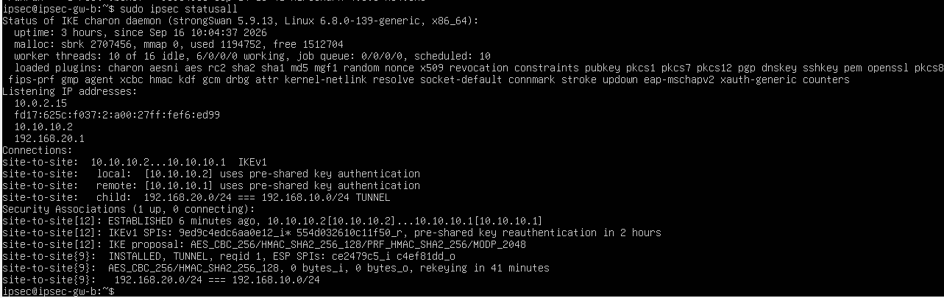
Figure 5.3. Site-to-Site IPsec Status After Successful Establishment
The figure also shows that the IKE proposal used AES_CBC_256, HMAC_SHA2_256_128, PRF_HMAC_SHA2_256, and MODP_2048, while ESP used AES_CBC_256 combined with HMAC_SHA2_256_128. These parameters were discussed theoretically in Chapter 4 and directly confirmed in the experimental environment.

5.3.3. Ikev1 main mode analysis
The ipsec_full.pcap file was opened in Wireshark and filtered for ISAKMP traffic. The first six negotiation packets were identified as Identity Protection (Main Mode). This is Phase 1 of IKEv1, responsible for negotiating policies, exchanging information for key generation, and authenticating the two peers before establishing the IKE SA [5].
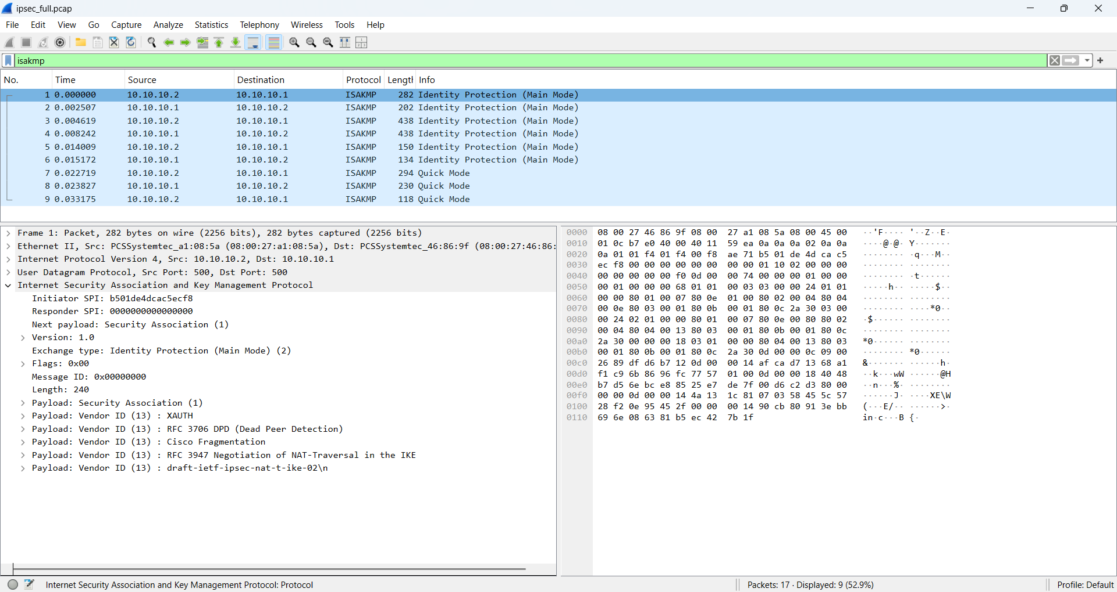
Figure 5.4. IKEv1 Main Mode Messages in Wireshark
In the packet details, Wireshark displays Exchange Type: Identity Protection (Main Mode). The observed proposal matches the experimental configuration: AES-CBC-256, SHA2-256, MODP 2048, and Pre-Shared Key authentication.

5.3.4. IKEv1 quick mode analysis
After Main Mode, the next three packets in ipsec_full.pcap were identified by Wireshark as Quick Mode. Quick Mode belongs to Phase 2 of IKEv1 and is used to negotiate parameters for the SAs that protect IPsec traffic [5].
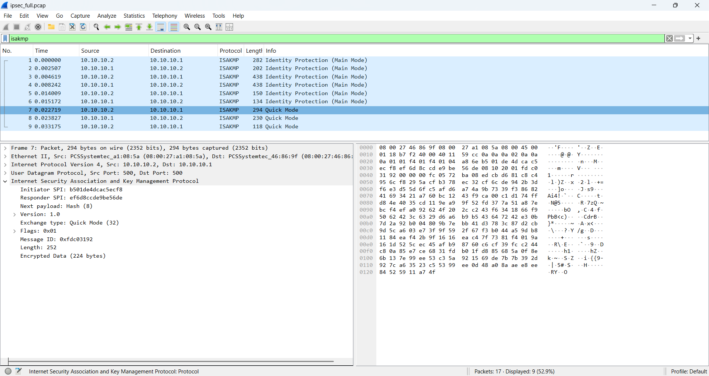
Figure 5.5. IKEv1 Quick Mode Process in Wireshark

5.3.5. ESP SA analysis
After Phase 2 was completed, traffic belonging to the two traffic selectors was processed using ESP Tunnel Mode. In Wireshark, ESP packets display the Security Parameters Index (SPI) and Sequence Number.
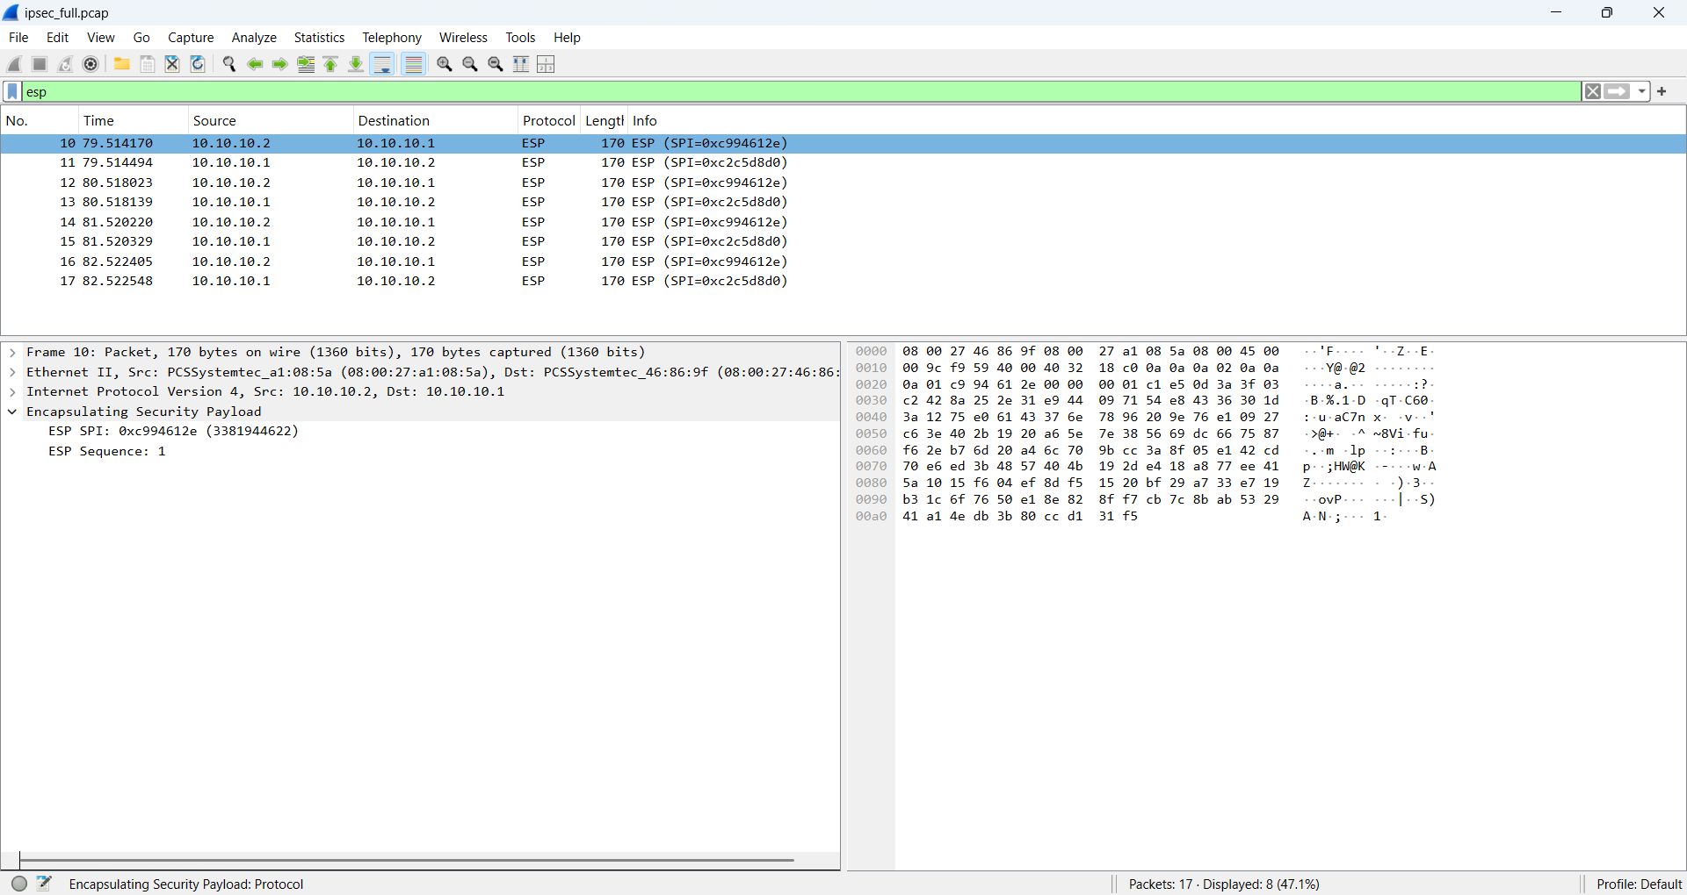
Figure 5.6. SPI and Sequence Number Fields of an ESP Packet
The SPI identifies the corresponding Security Association at the receiving endpoint, while the Sequence Number is associated with ESP’s anti-replay mechanism [4]. However, the project only observes these fields in captured packets and does not perform a replay attack; therefore, it does not provide an experimental conclusion about anti-replay capability. The outer IP addresses of the two gateways remain visible as 10.10.10.1 and 10.10.10.2. Therefore, the result must not be interpreted as meaning that “the entire packet is hidden.” ESP Tunnel Mode protects the inner IP packet, while the outer IP header and some ESP metadata remain observable on the WAN.

5.3.6. Traffic verification through the tunnel
After the tunnel was established, ICMP traffic was sent from GW-A to the LAN address of GW-B using ping -c 4 192.168.20.1. The result showed that all four packets were transmitted and received successfully, corresponding to 0% packet loss during this test. At the same time, the ESP counter in ipsec statusall increased, confirming that the traffic was processed by the SA.
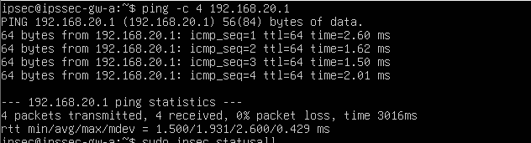
Figure 5.7. ICMP Connectivity Test Through the IPsec VPN
* The 0% packet-loss result reflects only four ICMP Echo packets in the virtual-machine environment at the time of testing. It must not be generalized as the system’s Availability rate.

5.3.7. Comparison of traffic at the lan and wan
To observe the effect of ESP Tunnel Mode, traffic was captured at two different locations. The lan_plain.pcap file shows traffic before it traverses the WAN segment, while wan_esp.pcap shows traffic on the network segment between the two gateways.
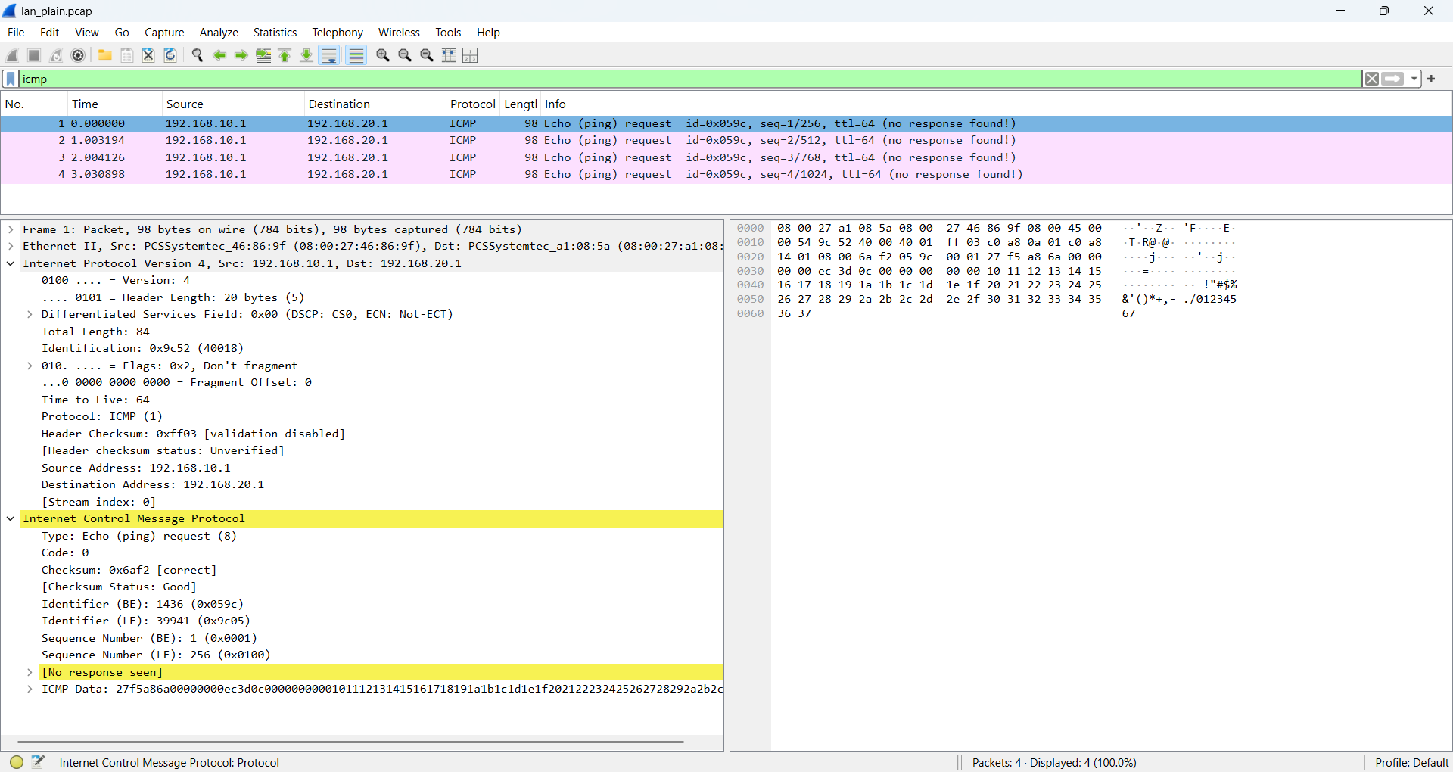
Figure 5.8. ICMP Packets Observed at the LAN Capture Point
At the LAN capture point, Wireshark can directly read source address 192.168.10.1, destination address 192.168.20.1, and the ICMP Echo Request protocol. The file records four Echo Requests; the absence of Echo Reply packets in the screenshot reflects only the content of that capture point/file and is not evidence of tunnel failure.
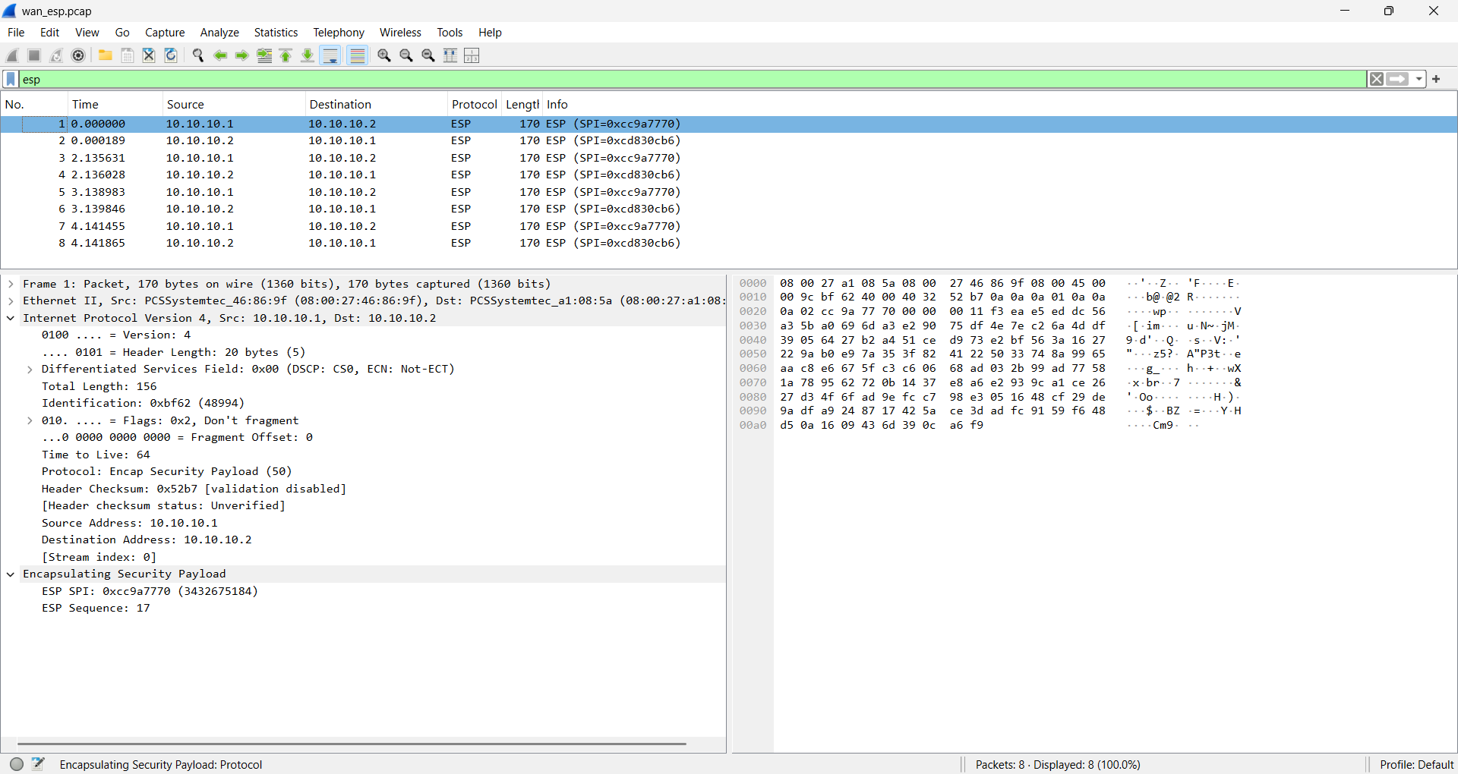
Figure 5.9. ESP Traffic Observed at the WAN Capture Point
At the WAN capture point, Wireshark observes eight ESP packets exchanged between 10.10.10.1 and 10.10.10.2. The inner IP header and ICMP are not directly visible as they are at the LAN point. Instead, Wireshark shows only the outer IP header and ESP information such as SPI and Sequence Number. When the two results are compared side by side, the following can be observed: LAN: 192.168.10.1 → 192.168.20.1 → ICMP; WAN: 10.10.10.1 ↔ 10.10.10.2 → ESP. This difference is important visual evidence of ESP Tunnel Mode encapsulation and traffic protection.

5.3.8. Pre-shared key mismatch test
To examine the role of the PSK in IKEv1 authentication, the PSK on one gateway was intentionally changed for a short period. The test was performed only on two virtual machines in a controlled environment. When the gateways used different PSKs, the IKE establishment process could not be completed. The strongSwan log recorded the following messages:
“invalid HASH_V1 payload length, decryption failed
could not decrypt payloads
message parsing failed”
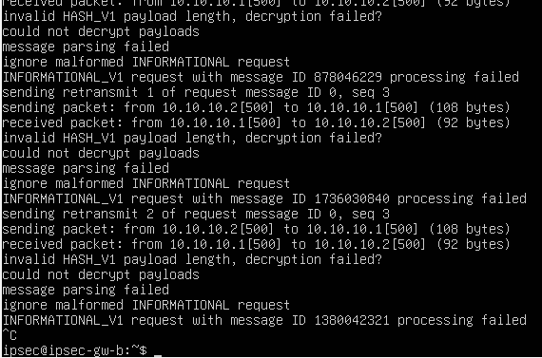
Figure 5.10. IKEv1 Negotiation Error When the Pre-Shared Key Does Not Match
The result shows that WAN connectivity still existed, but the IPsec tunnel did not reach the INSTALLED, TUNNEL state. This clearly distinguishes basic network connectivity from authentication and secure IPsec-channel establishment.
After the test, the original PSK was restored, credentials were reloaded on both gateways, and the pending IKE session was cleared. When ipsec up site-to-site was executed again, strongSwan reported:
“IKE_SA ... established
CHILD_SA ... established
connection 'site-to-site' established successfully”
The ipsec statusall output again displayed:
“ESTABLISHED
INSTALLED, TUNNEL”
Figure 5.11. IPsec Status After Restoring the PSK

5.4. Evaluation of results and limitations
The experimental results show that the model successfully established a Site-to-Site IPsec VPN between two Ubuntu gateways using IKEv1, a Pre-Shared Key, and ESP Tunnel Mode. The Main Mode and Quick Mode processes were directly observed in the PCAP file, while strongSwan status confirmed that the IKE SA and CHILD_SA had been established. Comparison of LAN and WAN traffic showed that ICMP was directly observable on the internal network, whereas WAN traffic appeared as ESP packets between the two gateways. The mismatched-PSK scenario caused authentication failure, and the tunnel was successfully re-established after the credentials were restored.
However, these results reflect only an experimental environment consisting of two virtual machines. A sample of four ICMP packets is insufficient to evaluate performance or long-term availability. The project did not test replay attacks, DoS, HTTP traffic, high load, latency, CPU usage, or communication between separate endpoint machines. Therefore, the report does not draw conclusions beyond the scope of the collected evidence.

CHAPTER 6. CONCLUSION AND FUTURE DIRECTIONS

6.1. Conclusion
The project configured two strongSwan gateways using IKEv1, a PSK, and ESP Tunnel Mode for two LAN subnets. SA status, ping results, ESP counters, and PCAP files demonstrate that the IPsec encapsulation mechanism operated in the model. An incorrect PSK prevented the session from completing, while restoring the key allowed the connection to operate again. For Management Information Systems students, the results illustrate how to protect communication channels between two departments and how to collect evidence for troubleshooting configuration issues.

6.2. Limitations and future directions
The model was tested using two virtual machines and does not yet include endpoint machines or business services. The test duration and number of ping samples are insufficient for performance evaluation. IKEv1 is not recommended for new deployments [6]; the next steps are to migrate to IKEv2, consider certificates instead of PSKs, add two endpoint machines for application-traffic measurement and fail-closed testing, and monitor logs across multiple sessions before evaluating anomaly detection.

CHAPTER 7. REFERENCES
[1] Duy Tan University, International School, Guidelines for Individual Capstone Project, CMU-CS 376, 2026–2027.
[2] S. Kent and K. Seo, “Security Architecture for the Internet Protocol,” RFC 4301, Dec. 2005. https://www.rfc-editor.org/rfc/rfc4301
[3] S. Kent, “IP Encapsulating Security Payload (ESP),” RFC 4303, Dec. 2005. https://www.rfc-editor.org/rfc/rfc4303
[4] D. Harkins and D. Carrel, “The Internet Key Exchange (IKE),” RFC 2409, Nov. 1998. https://www.rfc-editor.org/rfc/rfc2409
[5] strongSwan, Documentation. https://docs.strongswan.org/ (consulted for configuration and status commands).
[6] W. Stallings, Projects for Teaching Cryptography and Network Security, Appendix A, pp. 678–684.
[7] strongSwan, Documentation. https://docs.strongswan.org/ (consulted for configuration and status commands).

APPENDIX A. VERIFICATION COMMANDS AND EVIDENCE
A.1. Main verification commands
The main commands used during implementation and testing include:
- ip -br addr: checks IP addresses on the interfaces of both gateways.
- sudo ipsec statusall: checks IKE SA and CHILD_SA status, IKE/ESP proposals, and traffic selectors.
- sudo ipsec up site-to-site: initiates IKEv1 negotiation and establishes the IPsec tunnel.
- sudo ipsec down site-to-site loses the IPsec session before performing selected test scenarios
- sudo ipsec rereadsecrets: instructs strongSwan to reload authentication
- ping -c 4 10.10.10.2: verifies basic connectivity between the two gateways on the WAN network.
- ping -c 4 192.168.20.1: verifies ICMP traffic passing through the IPsec-protected domain
A.2. Configuration files
The submitted configuration set contains two folders:
- GW_A (gồm: ipsec_A.conf và ipsec.secrets.example.txt)
- GW_Bb (gồm: ipsec_B.conf và ipsec.secrets.example.txt)
The ipsec_A.conf and ipsec_B.conf files contain the strongSwan configuration used in the experimental model.
The actual Pre-Shared Key is not included in the report or public file set. The example file uses the following placeholder:
10.10.10.1 10.10.10.2 : PSK "<PRE_SHARED_KEY>" This shows the configuration structure without exposing the actual credential.
A.3. PCAP files
Three PCAP files are included to support verification of the results: ipsec_full.pcap; lan_plain.pcap; wan_esp.pcap:
- ipsec_full.pcap: records IKEv1 Main Mode, Quick Mode, and ESP packets.
- lan_plain.pcap: shows ICMP traffic at the LAN capture point.
- wan_esp.pcap: shows ESP traffic between the two gateways at the WAN capture point
A.4. Reproducibility scope
The interface addresses of the two gateways are shown in the supporting screenshots and the addressing table in Chapter 5. The report does not add routing or firewall parameters that were not directly collected during the experiment. Therefore, this appendix presents only the actual configurations, commands, and evidence that were recorded.

